**LAB Task 3**

WaterJug with DFS & printing rules

**Step 1 ) Function Definition**

• This function takes three parameters:

* capacity1: Maximum capacity of jug1
* capacity2: Maximum capacity of jug2
* target: The amount of water we need to measure

• We will use **Depth-First Search (DFS)** to explore different ways to measure the target.

**Step 2 ) Initializing Data Structures**

• **stack**: A stack is used for **DFS traversal**. It starts with (0,0), meaning both jugs are empty.

• **visited**: A set to store states that we have already checked (to prevent infinite loops).

• **path**: A list to store the sequence of moves.

**Step 3 ) DFS Loop - Exploring Different States**

Store (jug1, jug2) in the path list to track the sequence

**Step 4 ) Checking if We Reached the Target**

This list contains **all possible actions**:

1. **Fill jug1** completely.
2. **Fill jug2** completely.
3. **Empty jug1**.
4. **Empty jug2**.
5. **Pour jug1 into jug2** (until jug2 is full or jug1 is empty).
6. **Pour jug2 into jug1** (until jug1 is full or jug2 is empty)

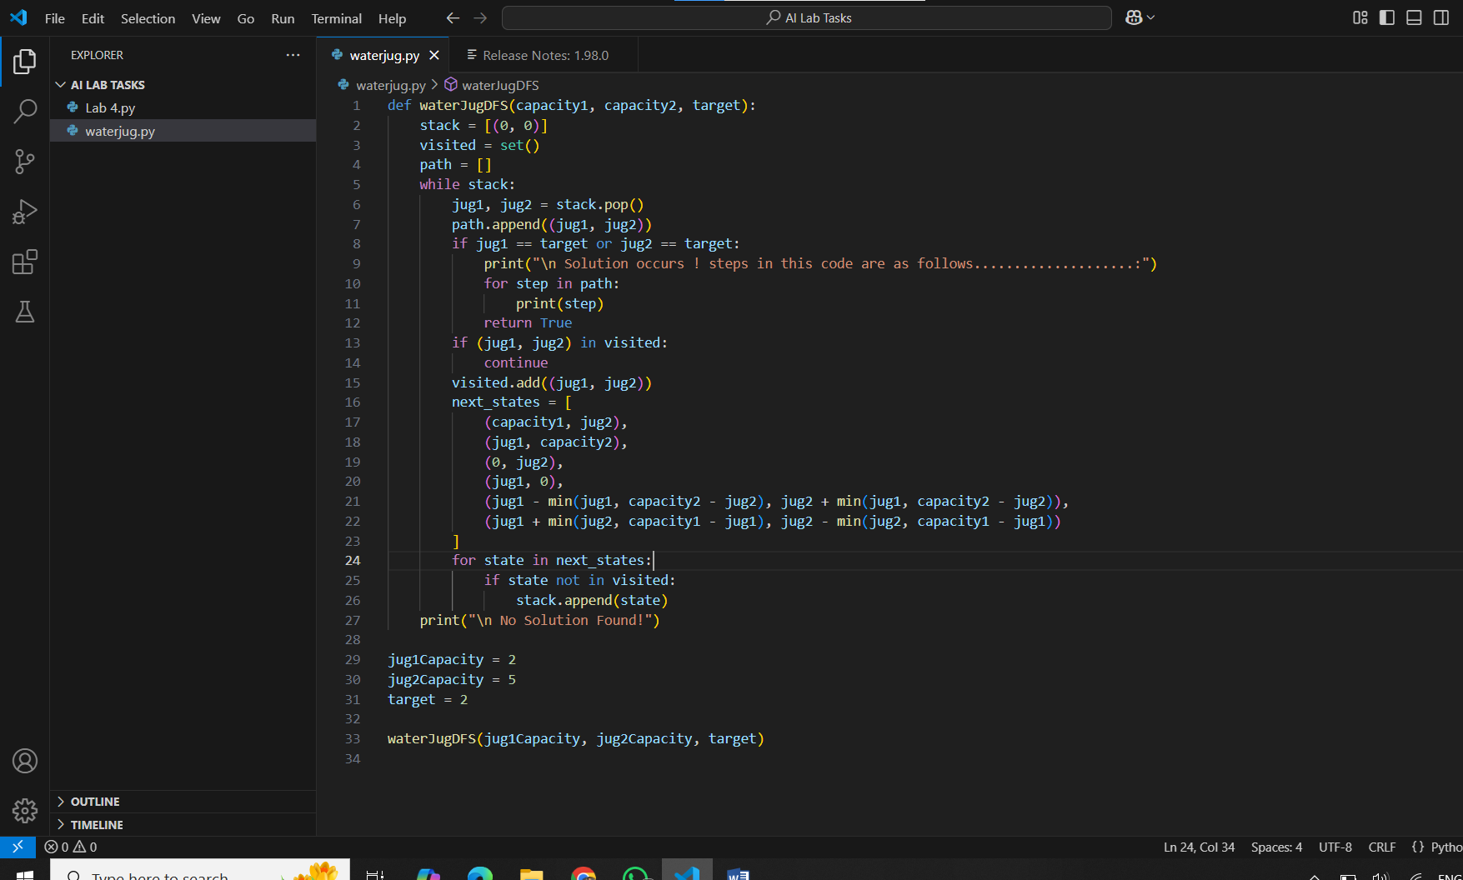

**Step 5 ) Output**

This calls the function with:

* **Jug1 capacity = 2 liters**
* **Jug2 capacity = 5 liters**
* **Target = 2 liters**

